1. Is your browser running HTTP version 1.0 or 1.1?

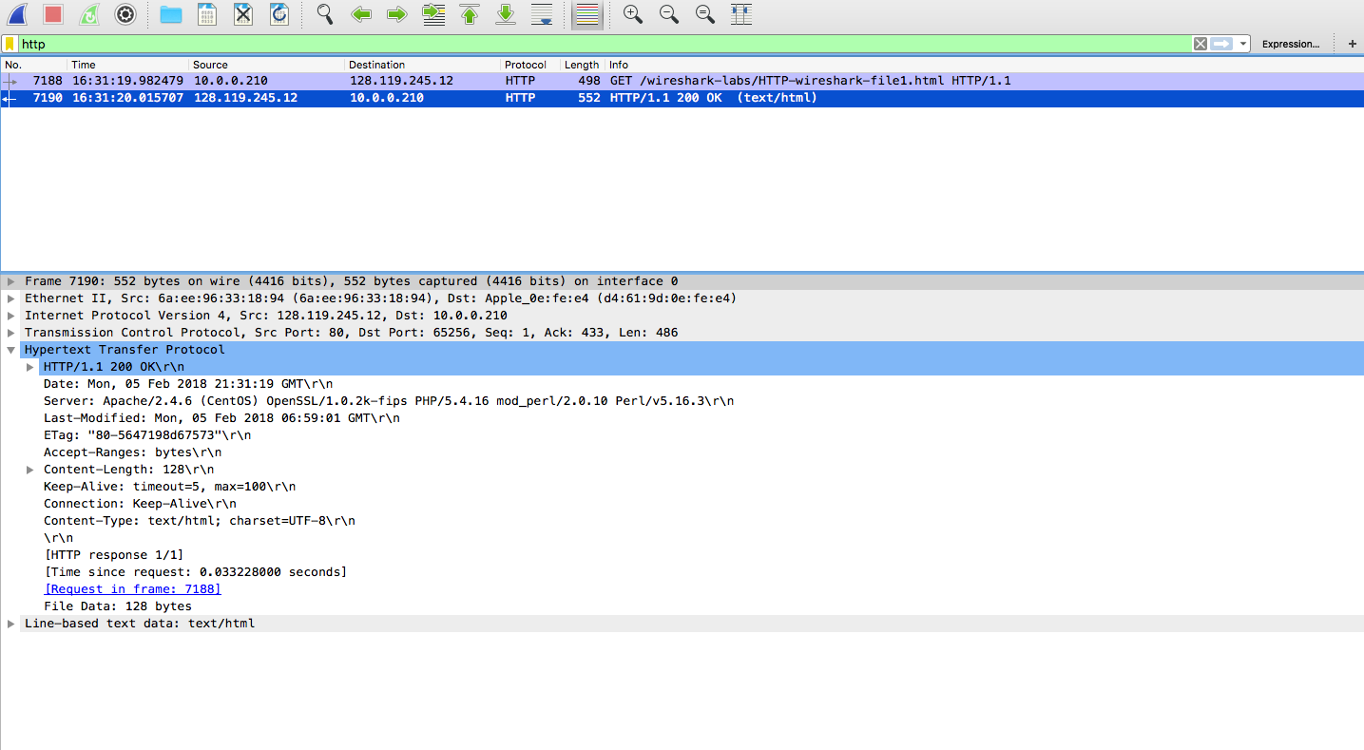

The HTTP version is 1.1 seen in the screenshot above.

1. When was the HTML file that you are retrieving last modified at the server?

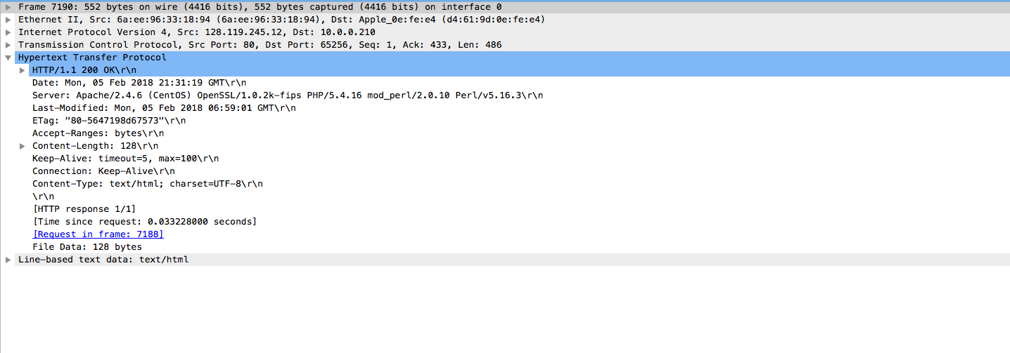Last modified at the server on Feb, 05,2018. 21:31:19 GMT

3.What is the IP address of your computer? Of the gaia.cs.umass.edu server?

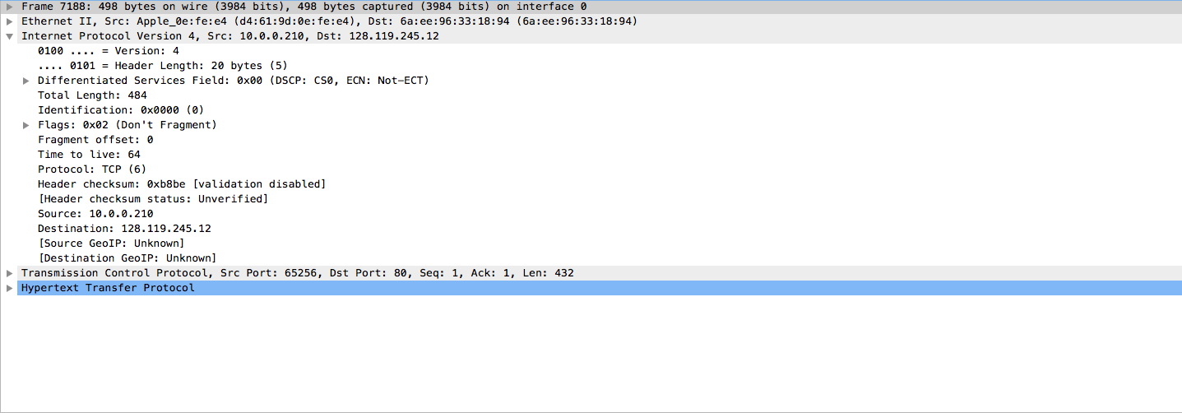

The IP address is the Source in the Screen shot above and the gaia.cs.umass.edu IP address is the destination.

Computer; 10.0.0.210

Server; 128.119.245.12

1. What languages (if any) does your browser indicate that it can accept to the server?

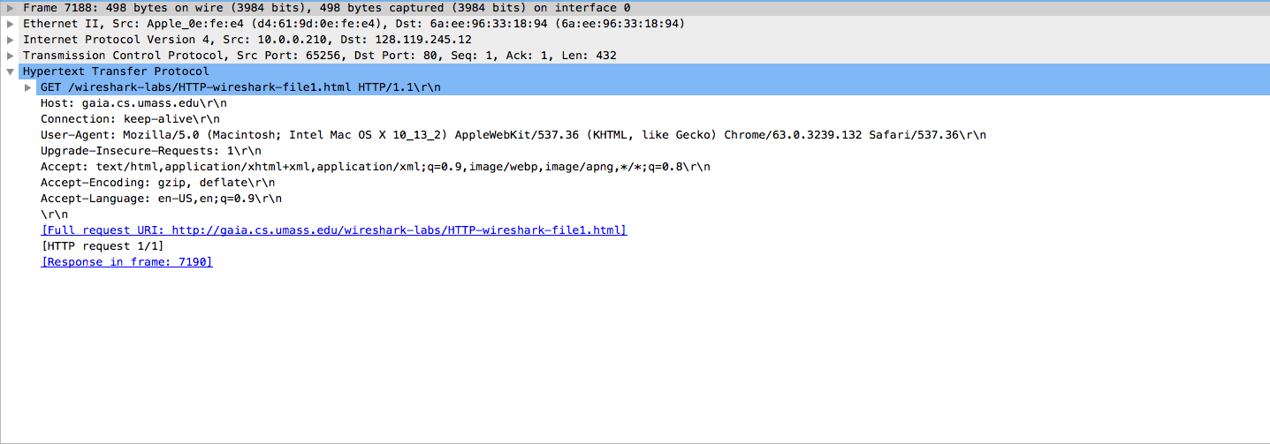

Accepted language is : en-US, en; q =0.9\r\n

American English